Version

C# 2.0–.NET Framework 2.0 , VS 5
- Generics
- Partial types
- Anonymous methods
- Iterators
- Nullable types
- Private setters (properties)
- Method group conversions (delegates)
- Covariance and Contra-variance
- Static classes

C# 3.0 –.NET Framework 2.0/3.0/3.5 , VS 10,8
- Implicitly typed local variables
- Object and collection initializers
- Auto-Implemented properties
- Anonymous types
- Extension methods
- Query expressions
- Lambda expressions
- Expression trees
- Partial Methods
- Var Keyword

C#4.0 –.NET Framework 4.0 , VS 10 ,CLR-4.0
- Dynamic binding
- Dynamic Keyword
- Named and optional arguments
- Generic co- and contravariance
- Embedded interop types ("NoPIA")

C# 5.0 –.NET Framework 4.5 , VS 12, 13, CLR-4.5
- Asynchronous methods
- Caller info attributes

C# 6.0

Differences

Async/Await
- use the async and await keywords to asynchronously run a method
- 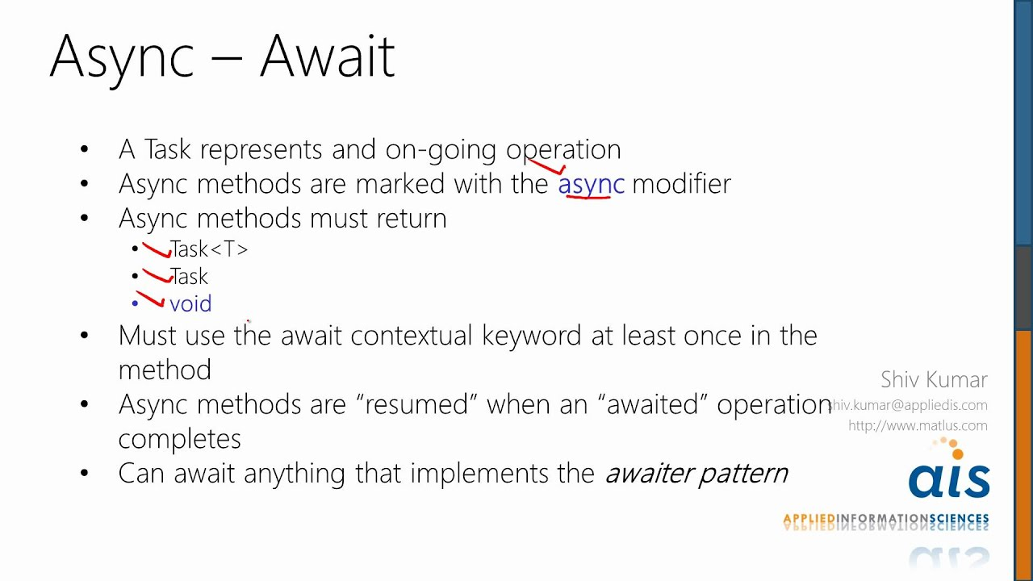
- in asynchronous call, calling method doesn’t get blocked, and they can run simultaneously with called method.

Const vs. Readonly vs. Static
Constants:

- Static by default
- Must have compilation-time value
- A const field can only be initialized at the declaration of the field
- const field is a compile-time constant

Readonly instance fields:

- A readonly field can be initialized either at the declaration or in a constructor
- Are evaluated when instance is created
- Must have set value by the time constructor exits
- readonly field can be used for runtime constants

Interface Vs abstract class?
Interface :
- Interface have only Signature. No body
- All the Methods are Public , It doesn't have access Modifier Controls
- Support multiple inheritance
- All the Methods are Abstract by default
- It does not have Constructor, destructor, Fields/variable
- A Class May inherits several Interfaces - multiple inheritance

Abstract Class:
- Abstract Class have Method definition and Implementation-have body
- It can have Access Modifier
- It does not allow multiple Inheritance
- Some methods can be concrete –No body
- It have constructor and destructor
- Does not support multiple inheritance

Finalize vs dispose method?
Finalize:
- Finalize () is called by the runtime
- Is a destructor, called by Garbage Collector when the object goes out of scope.
- Implement it when you have unmanaged resources in your code, and want to make sure that these resources are freed when the Garbage collection happens.
Dispose :
- Dispose () is called by the user
- Same purpose as finalize, to free unmanaged resources. However, implement this when you are writing a custom class, that will be used by other users.
- Overriding Dispose() provides a way for the user code to free the unmanaged objects in your custom class.

static class vs sealed class

Static class
- can not create instance
- can not inherit it.
- can not have base class
- can contain only static member
- access its member directly with class name
- A static class is neither abstract nor sealed as it does not participate in inheritance.
Seal class
- can create instance
- can not inherit it
- can have base class
- can contain both static and non static members
- need new keyword and instance to access its non static member

Value type vs Reference Type?

Value Type:
- In value type the value is stored on the stack and can be used directly.
- It contain value directly not the memory reference of value
- Value type cannot be null,
- default value for this is zero [0].
- Memory of variables in value type is automatically freed.
- Int , float, byte are value type

Reference Types

- Reference type can be null and memory of the variables are not automatically freed ,
- it needs a garbage collector to do this.
- Reference types stores the reference to the data, unlike value types, that stores the value.
- class. delete, interface, array , new keyword is reference type

Overriding vs overloading?
OVERLOADING is the process of declaring the methods having
the same name but diff signatures. Signature means diff
types & number of arguments.
OVERRIDING is the process of overwriting the methods of
base class in Derived Class. Or giving new implementation in derived class.

== vs .Equals()
For Value Type:
== and .Equals() method usually compare two objects by value.

For string data type
It always does content comparison. In other words you either use “.Equals()” or “==” it always do content comparison.

For Reference Type:
== performs an identity comparison, i.e. it will only return true if both references point to the same object.

Equals () method is expected to perform a value comparison, i.e. it will return true if the references point to objects that are equivalent.

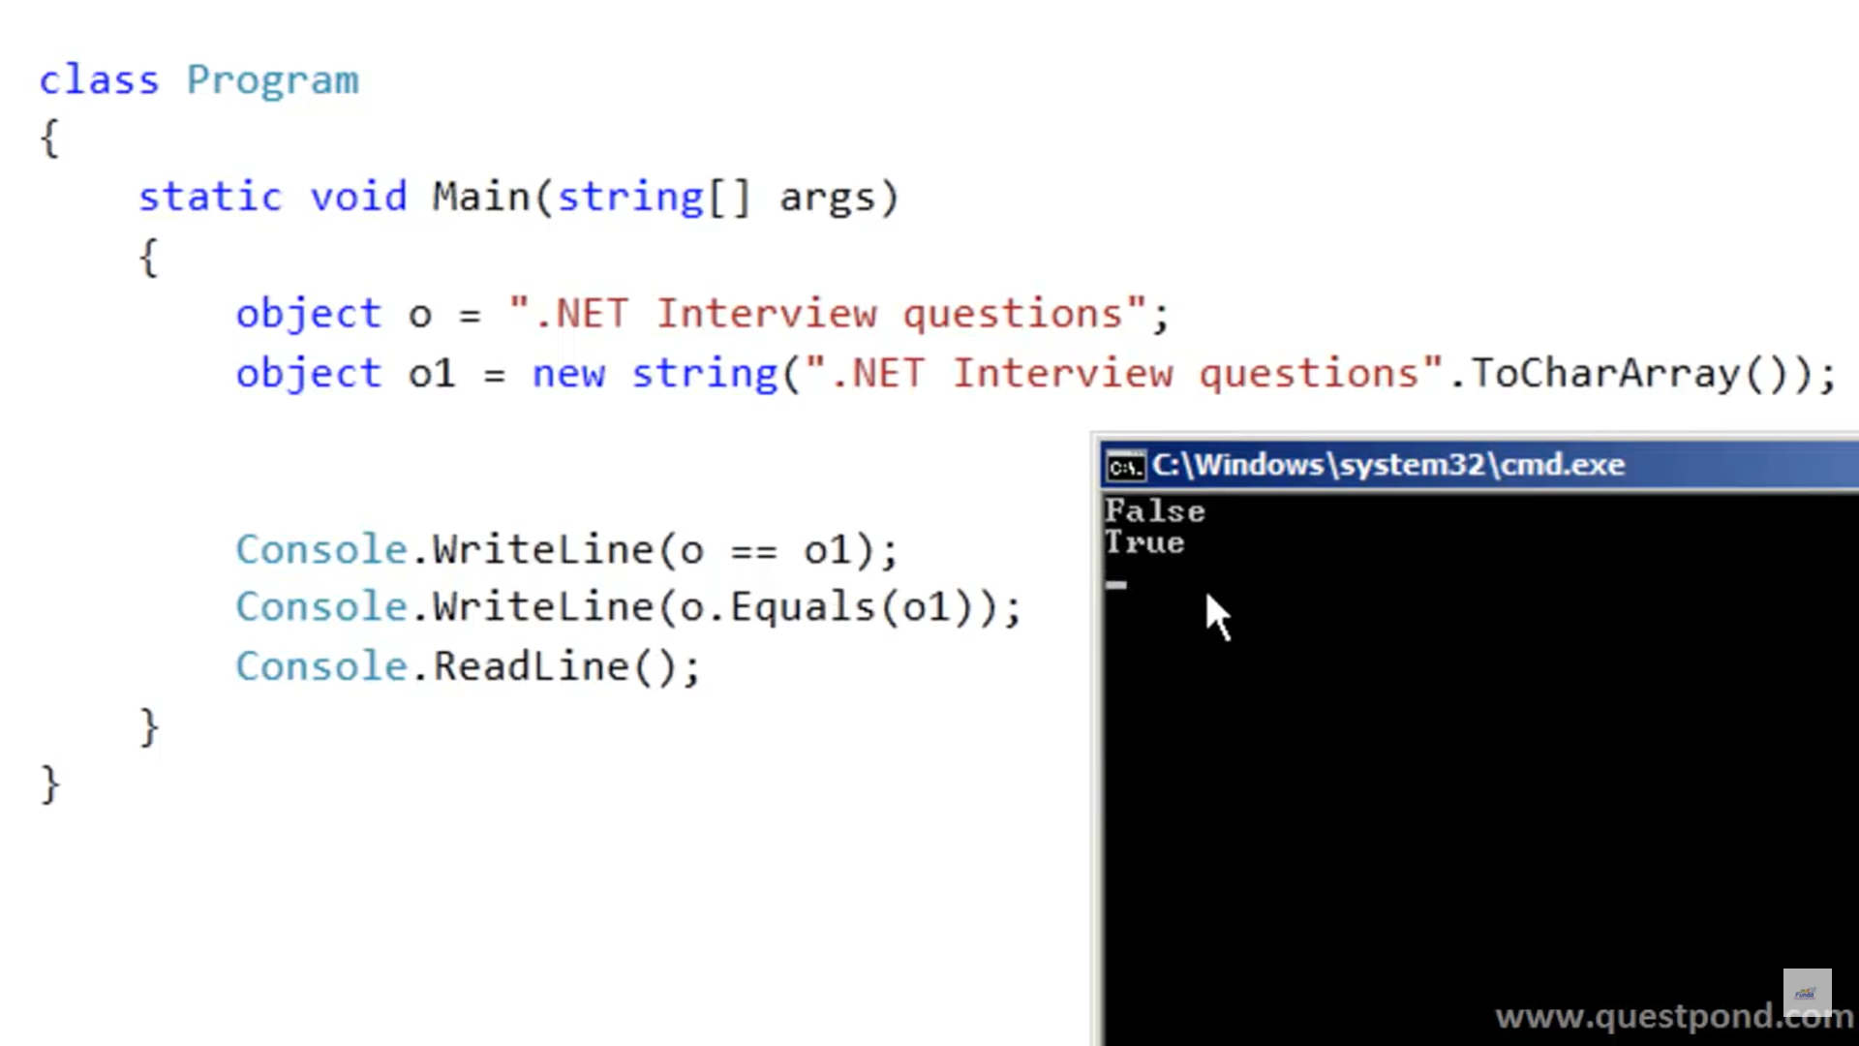
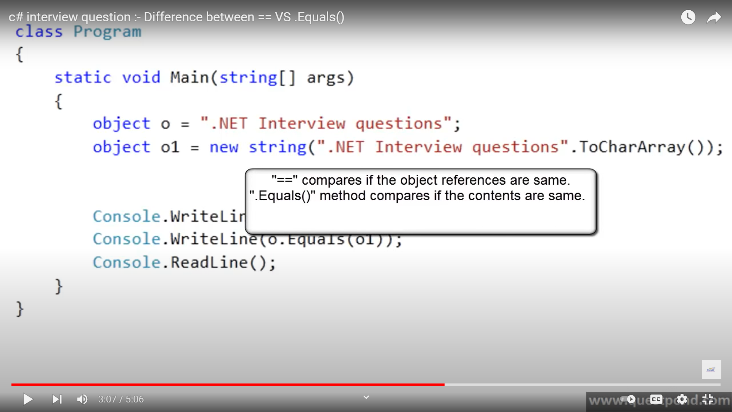

Close() Vs Dispose Method
- When a Close() method is called, any managed resource can be temporarily closed and can be opened once again.It means that, with the same object the resource can be reopened or used.
- Where as Dispose() method permanently removes any resource ((un)managed) from memory for cleanup and the resource no longer exists for any further processing.

Difference between Struct and Class
Struct
- Struct are Value type and are stored on stack
- Struct “do not support” inheritance, However struct can implements interface.
- Struct should be used when you want to use a small data structure,
Class
- Class are Reference type and are stored on heap.
- Class supports inheritance.
- Class is better choice for complex data structure.

Throw vs throws ex
- Throw ex does not preserve the stack trace
- Throw preserves the stack trace.
  - It's better to use throw instead of throw ex

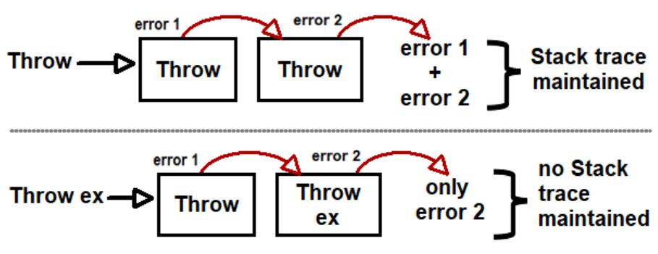

IEnumerable vs IQueryable
Both these interfaces are for .NET collection’s, The first important point to remember is “IQueryable” interface inherits from “IEnumerable”, so whatever “IEnumerable” can do, “IQueryable” can also do.
“IQueryable” interface is useful when your collection is loaded using LINQ or Entity framework and you want to apply filter on the collection.

EmpEntities ent = new EmpEntities();
IEnumerable<Employee> emp = ent.Employees;
IEnumerable<Employee> temp = emp.Where(x => x.Empid == 2).ToList<Employee>();

all the data is fetched from the database and then at the client its scans and gets the record with “EmpId” is “2”.

EmpEntities ent = new EmpEntities();
IQueryable<Employee> emp = ent.Employees;
IQueryable<Employee> temp = emp.Where(x => x.Empid == 2).ToList<Employee>();

In IQueryable case the filter is applied on the database using the “SQL” query. So the client sends a request and on the server side a select query is fired on the database and only necessary data is returned.

So the difference between “IQueryable” and “IEnumerable” is about where the filter logic is executed. One executes on the client side and the other(Iqueryable) executes on the database.

So if you working with only in-memory data collection “IEnumerable” is a good choice but if you want to query data collection which is connected with database “IQueryable” is a better choice as it reduces network traffic and uses the power of SQL language.

IEnumerable” vs “IEnumerator

List<int> ages = new List<int>();
ages.Add(10);ages.Add(20);ages.Add(30);ages.Add(40);ages.Add(50);

IEnumerable<int> age_IEnumerable = (IEnumerable<int>)ages;
foreach (int age in age_IEnumerable)
Console.WriteLine(age);

IEnumerator<int> age_IEnumerator = ages.GetEnumerator();
while (age_IEnumerator.MoveNext())
Console.WriteLine(age_IEnumerator.Current);

As you can see here we used while rather than foreach because foreach cannot be used with IEnumerator

IEnumerable doesn’t remember the state, which row or record it is iterating while IEnumerator remember it

Conclusion:
- Both are interface
- IEnumerable code are clear and can be used in foreach loop
- IEnumerator use While, MoveNext, current to get current record
- IEnumerable doesn’t remember state
- IEnumerator persists state means which row it is reading
- IEnumerator cannot be used in foreach loop
- IEnumerable defines one method GetEnumerator which returns an IEnumerator
- IEnumerator allows readonly access to a collection
http://www.advancesharp.com/blog/1053/ienumerable-and-ienumerator-in-c-with-example

OOPS
- Abstraction
- Encapsulation
- Inheritance
- Polymorphism
- Association, Aggregation, Composition

which constructor will fire first in a parent-child relationship

In what instances you will declare a constructor to be private?

What is Polymorphisms
Polymorphisms is the ability of object to behave differently in different context , like obj.Draw() will draw two different things based on kinds of object at runtime
There are two types of Polymorphism.
Static (Compile Time) : function or operator overloading
Dynamic(Runtime) : Inheritence & virtual functions

What is Abstract method
Abstract method is method which doesn't have the implementation of their own & forces the derived class to override the Method

What is Virtual method?
Virtual Method has implementation & provide the derived class with the option to override it.

Can Struct be inherited?
No, Struct can't be inherited as this is implicitly sealed.

What is Virtual keyword?
This keyword indicates that a member can be overridden in a child class. It can be applied to
methods, properties, indexes and events.
class Program
{
static void Main(string[] args)
{
A a1 = new A();
a1.a();
A a = new B();
a.a();
Console.Read();
Output : A.a
B.a

}
}
class A
{
public virtual void a()
{
Console.WriteLine("A.a");
}
}
class B : A
{
public override void a()
{
Console.WriteLine("B.a");
}
}

What is New modifiers?
The new modifiers hides a member of the base class.
class Program
{
static void Main(string[] args)
{
A a1 = new A();
a1.a();
A a = new B();
a.a();
Console.Read();
Output : A.a
A.a
}
}

class A
{
public void a()
{
Console.WriteLine("A.a");
}
}
class B : A
{
public new void a()
{
Console.WriteLine("B.a");
}
}

When to use Interface over abstract class?
-- When there is no implementation have to be provided by base class
-- Only have to force derive class to strickly implement certain method

Default Access modifiers in C#?
An enum has default modifier as public
A class has default modifiers as Internal .
An interface has default modifier as public
A struct has default modifier as Internal
A methods, fields, and properties has default access modifier as "Private" if no modifier is
specified.

What is method overloading
There can be more than one method with same name but different signature(type and sequence ) return type is not considered in this .

What is Overriding?
It is process of giving new implementaion of virtual method of base class in derive class.

What is a private constructor? Where will you use it?
When you declare a Constructor with Private access modifier then it is called Private Constructor.
We can use the private constructor in singleton pattern.
If you declare a Constructor as private then it doesn’t allow to create object for its derived class, i.e you loose inherent facility for that class.

What Are Attributes in DotNet?
An Attribute is a declarative tag which can be used to provide information to the compiler about the behaviour of the C# elements such as classes and assemblies.
C# Provides many Built-in Attributes

Some Popular ones are

- Obsolete
- DllImport
- Conditional
- WebMethod

Diversities between an abstract method & virtual method ?
--An Abstract method does not provide an implementation and forces overriding to the deriving
class (unless the deriving class also an abstract class),
-- virtual method has an implementation and leaves an option to override it in the deriving class. Thus Virtual method has an implementation & provides the derived class with the option of overriding it.
-- Abstract method does not provide an implementation & forces the derived class to override the method.

What is Early binding and late binding?
Calling a non-virtual method, decided at a compile time is known as early binding. Calling a virtual
method (Pure Polymorphism), decided at a runtime is known as late binding.

What is Abstract Class?
- Abstract class can not be instantiated,
- An abstract class contain abstract members as well as non-abstract members.
- An abstract class cannot be a sealed class because the sealed modifier prevents a class from being inherited and the abstract modifier requires a class to be inherited.
- A non-abstract class which is derived from an abstract class must include actual implementations of all the abstract members of parent abstract class.
- An Abstract class can has access modifiers like private, protected, internal with class members. But abstract members cannot have private access modifier.
- An Abstract class can has instance variables (like constants and fields).(interface)
- An abstract class can has constructors and destructor.(Interface )
- An abstract class cannot support multiple inheritance.(Inteface)
- it exists extensively for inheritance.
- An abstract method is implicitly a virtual method.
- An abstract class cannot be inherited by structures.
- Abstract classes cannot be used to instantiate objects; because abstract classes are incomplete, it
- may contain only definition of the properties or methods and derived classes that inherit this
- implements it's properties or methods.
- The purpose of an abstract class is to provide basic or default functionality as well as common functionality that multiple derived classes can share and override.

- Static, Value Types & interface doesn't support abstract modifiers.
- Static members cannot be abstract.
- Classes with abstract member(Method) must also be abstract.

Common design guidelines for Abstract Class
--Don't define public constructors within abstract class. Since abstract class cannot be instantiate and constructors with public access modifiers provides visibility to the classes which can be instantiated.
--Define a protected or an internal constructor within an abstract class. Since a protected constructor allows the base class to do its own initialization when sub-classes are created and an internal constructor can be used to limit concrete implementations of the abstract class to the assembly which contains that class.
When to use
--Need to create multiple versions of your component since versioning is not a problem with abstract class. You can add properties or methods to an abstract class without breaking the code and all inheriting classes are automatically updated with the change.
--Need to to provide default behaviors as well as common behaviors that multiple derived classes can share and override.

What is an Interface?
- An interface is a contract & defines the requisite behavior of generalization of types.
- An interface mandates a set of behavior, but not the implementation, only have signature
- We can't create an instance of an interface.
- An interface function/property must be implemented in derived type.
- It cannot contains constants members, constructors, instance variables, destructors, static members or nested interfaces.
- It contains only properties, indexers, methods, delegates and events signature.
- Members of an interface are implicitly public & abstract.
- Implicitly, every member of an interface is public and abstract. Also, you are not allowed to specify the members of an interface public and abstract or virtual.
- A class or struct can implements more than one interfaces.
- It doesn't have access Modifier Controls
- An interface can inherit from another interface.
- An interface support multiple inheritance.
- The most common use of interfaces is, within SOA (Service Oriented Architecture). In SOA (WCF), a service is exposed through interfaces to different clients
- A class that implements an interface can mark any method of the interface as virtual and this method can be overridden by derived classes.
- Implementing multiple interfaces by a class, sometimes result in a conflict between member signatures. You can resolve such conflicts by explicitly implementing an interface member.
public class Document : IA, IB
{

public void IA.a()
{
Console.WriteLine("IA.a");
}
public void IB.a()
{
Console.WriteLine("IB.a");
}
}
When to use
- Need to provide common functionality to unrelated classes.
- Need to group objects based on common behaviors.
- Need to introduce polymorphic behavior to classes since a class can implements more than one interfaces.
- Need to provide more abstract view to a model which is unchangeable.
- Need to create loosely coupled components, easily maintainable and pluggable components (like log4net framework for logging) because implementation of an interface is separated from itself.
Disadvantage of Interface
- The main issue with an interface is that when you add a new members to its, then you must implement those members within all of the classes which implement that interface.
- Interfaces are slow as these required extra in-direction to find corresponding method in in the actual class.

Basic

Static Concept

Key points about Static keyword
- If the static keyword is applied to a class, all the members of the class must be static.
- Static methods can only access static members of same class. Static properties are used to get or set the value of static fields of a class.
- Static constructor can't be parameterized and public. Static constructor is always a private default constructor which is used to initialize static fields of the class.

Static Members of the class
“static members” belong to the whole class rather than to individual object

How to access static member of class?
Static members are accessed with the name of class rather than reference to objects. Example: className.StaticMemberName

Static Method of the class
- Static Method can be called directly without first creating an instance of a class.
- You can use static fields, methods, properties and even constructors which will be called before any instance of the class is created.
- you can not use instance members inside static methods or properties,
- you may call a static member from a non-static context. The reason for being able to call static members from non-static context is that static members belong to the class and are present irrespective of the existence of even a single object.

Static Constructor
In C# it is possible to write a static no-parameter constructor for a class. Such a class is executed once, when first object of class is created.
One reason for writing a static constructor would be if your class has some static fields or properties that need to be initialized from an external source before the class is first used.

When to use “==” operator and “.Equals()” method?
For Value comparison,
- with Value Type use “==” operator
- with Reference Type use use “Equals()”
For Reference comparison
- with Reference Type use use “==” Operator

Why and When to Use an abstract class
When creating a class library which will be widely distributed or reused—especially to clients, use an abstract class in preference to an interface; because, it simplifies versioning. This is the practice used by the Microsoft team which developed the Base Class Library. (COM was designed around interfaces.)
Need to create multiple versions of your component since versioning is not a problem with abstract class. You can add properties or methods to an abstract class without breaking the code and all inheriting classes are automatically updated with the change. Need to to provide default behaviors as well as common behaviors that multiple derived classes can share and override.

Choosing between struct and class
struct
When you have small data structure
Data Structure does not require to extent the functionality.
When you want to perform faster operation on data structure. (As structure are stored on stack, operation performed on it are faster.)
class
When you have complex data structure
Data Structure requires to extend functionality.
When you want to optimize memory usage. (As class is stored on heap, they are about to be garbage collected when no reference pointing to an object.)

What is the difference between instantiating structures with and without using the new keyword?
--When a structure is instantiated using the new keyword, a constructor (no-argument or custom, if provided) is called which initializes the fields in the structure.
--When a structure is instantiated without using the new keyword, no constructor is called. Hence, one has to explicitly initialize all the fields of the structure
before using it when instantiated without the new keyword.

Intermediate

What is delegate & Its use

Delegate
- Delegate is a reference type that hold reference of a method which has same parameter list and return type.
- Delegates allow methods to be passed as parameters.
Delegates are two types
- Single Cast Delegates
- Multi Cast Delegates
Single Cast Delegates
Single cast delegate means which hold address of single method like as explained in above example.
Multicast Delegates
Multi cast delegate is used to hold address of multiple methods in single delegate. To hold multiple addresses with delegate we will use overloaded += operator and if you want remove addresses from delegate we need to use overloaded operator -=
Multicast delegates will work only for the methods which have return type only void. If we want to create a multicast delegate with return type we will get the return type of last method in the invocation list
MultiDelegate del = Sampleclass.Add;
del += Sampleclass.Sub;
del += Sampleclass.Mul;
del(10, 5);

There are 3 steps in Using Delegates
1).Declaration
2).Instantiation
3).Invocation
Namespace DelegateTest
{
//Declaration
Public Delegate Void DelegateAddition(int X, int Y);
Class AddNumbers
{
Public Void Add(int a, int b)
{
return a+b;
}
public Static Void Main()
{
//Instantiation
DelegateAddition da=new DelegateAddition(Add);
//Invocation
da(7, 1);
}
}
}
Event handlers
Event handlers are nothing more than methods that are invoked through delegates

Explain Lazy Loading in C#

Advanced

Practical

Two interface having same method , implemented by class , is it possible
namespace ConsoleApplication1
{
// compile sucessfully
class Program : Test1, Test2
{
static void Main(string[] args)
{
}
public void a(int a)
{
throw new NotImplementedException();
}

void Test2.a(int a)
{
throw new NotImplementedException();
}
}

interface Test1
{
void a(int a);
}
interface Test2
{
void a(int a);
}
}

2.0

3.0

Implicitly typed local variables
var presidentList = GetList();

Object and collection initializers
List<string> lst = new List<string> {“test”,”test1”};
Collection Initializer
List<President> list = new List<President>
{
// C# 3.0 Feature: Object Initializer
new President { PresidentID = 1, FirstName = "George", LastName = "Washington"}
}

Auto-Implemented properties
Public string empName {get;set;}

Anonymous types
Var tst1= new {id=1,name=’prahb’}

Extension methods
Static class
Static string method(this string )

Query expressions

Lambda expressions
var result = presidentList.Where(p => p.LastName.StartsWith("M"));

Expression trees

Partial Methods

3.5

4.0

5.0

3 new features available in .NET Framework 4.5?
1) Set Default culture to App Domain

In the previous versions of .NET if I need to set culture I need to do it on every thread. Below is a sample code which demonstrates the pain of setting culture at thread levels.That was a real pain when we have heavy multi-threaded application.

CultureInfo cul = new CultureInfo(strCulture);
Thread.CurrentThread.CurrentCulture = cul;
Thread.CurrentThread.CurrentUICulture = cul;

In 4.5 we can set culture at the app domain level and all the threads inside that appdomain will inherit that culture. Below is a sample code of how to implement “DefaultThreadCurrentCulture”.

CultureInfo culture = CultureInfo.CreateSpecificCulture("fr-FR");
CultureInfo.DefaultThreadCurrentCulture = culture;

2) Array support more than 2 Gigabyte size

